Mapping western Oregon Douglas-fir foliage retention with a simultaneous autoregressive model

Greg Latta, Department of Forest Engineering, Resources and Management, OSU.
Darius Adams, Department of Forest Engineering, Resources and Management, OSU.
Dave Shaw, Department of Forest Engineering, Resources and Management, OSU.

Abstract

Douglas-fir needle retention along the Oregon and SW Washington coasts is directly related to tree productivity, and also reflects severity of Swiss needle cast foliage disease. Using data gathered on 295 plots in western Oregon and southwestern Washington along with PRISM climate we estimate Douglas-fir needle retention via a simultaneous autoregressive model. Years of needle retention, is explained using January temperature and precipitation in excess of evapotranspiration in the month of July. The predictive ability of the model was tested by randomly dividing the data into 148 reference plots and 147 target plots two hundred times. Each imputation method was evaluated by calculating the correlation of actual and predicted values, bias, and root mean square error of both the target and reference data set. We also test for evidence of spatial autocorrelation. The model was then used the generate maps of Douglas-fir needle retention for forestland in western Oregon.

Introduction

Douglas-fir in western Oregon and SW Washington is currently experiencing foliage loss and growth impacts from a foliage disease known as Swiss needle cast, caused by Phaeocryptopus gaeumannii (Hansen et al. 2000, Maguire et al. 2002). The disease causes occlusion of the stomates, resulting in carbon starvation and subsequent foliage loss (Manter et al. 2003a). Disease severity has been measured as the amount of foliage retained, fungus fruiting body numbers, biomass of fungus within the needle, and molecular quantification (Winton et al. 2003, Manter et al. 2003b, Maguire et al. 2002). . All these factors are closely correlated in the zone of the SNC epidemic.

Foliage retention in years is directly related to tree growth in Douglas-fir of coastal Oregon (Maguire et al. 2002). If a tree has 3 years of foliage or more, it is likely growing at expected productivity. However, as needle retention decreases below 3 years, growth declines proportionally. Significant growth losses, over 50%, occur when foliage retention is less than one year. This fact has been used to simplify stand examination when determining the impact of disease on a forest plantation. Foliage retention is now an input for the ORGANON growth model (Hann 2006, Garber et al. 2007), and has been used to develop a spreadsheet tool for assessing stand impacts from Swiss needle cast disease (Mainwaring, SNCC Website, Stand Assessment Tool: http://www.cof.orst.edu/coops/sncc/Stand%20Growth%20Assessment%202.81.xls).

Foliage retention is the primary predictive tool used to estimate growth loss due to foliage disease in coastal Douglas-fir. Therefore, developing a needle retention landscape predictive model as a substitute for Swiss needle cast disease severity has been a goal of the Swiss Needle Cast Cooperative, a research and management cooperative housed in the Department of Forest Engineering, Resources and Management at Oregon State University (with members from forest landowners, Oregon Department of Forestry, US Forest Service, and Bureau of Land Management) (Website: http://www.cof.orst.edu/coops/sncc/index.htm)

Needle retention is influenced by a range of factors, especially site productivity and elevation (Reich ). Fertilizers also may influence needle retention, with additions of N decreasing foliage retention in one Douglas fir study (Brix ). The Oregon coast range has a steep gradient of nitrogen and calcium (Perakis et al. ). Calcium is adequate on the eastern slopes and deficient at the coast, while N is less than adequate on the eastern slope and more than sufficient near the coast. Precipitation is high on the coast, peaks at the coast range crest, and declines on the east slope to the treeless valley.

The objective of this work was to create a foliage retention landscape map to predict the distribution of disease impacts from Swiss needle cast, a foliage disease of Douglas-fir. The model is quite important as a qualitative tool to understand whether a particular forest stand is at risk from disease. However, it also allows a quantitative assessment of landscape growth impacts for productivity, economic and market analysis, while this type of map can also provide the basis for climate change modeling.

Methods

Plot data

Needle retention was assessed by visually estimating the number of years of foliage retained to the nearest 1/10th of a year. In Douglas-fir, each annual cohort of needles is distinct, and careful examination of the branchlet allows an assessment of whether foliage has fallen off. A branch from the south aspect of the tree, and in the middle to upper third (at least the 5th whorl down however) was examined, using a > 3yr old lateral branch, not the apex. This was either from collecting the branch with climbers or observing with binoculars from the ground.

The datasets used included;

Maguire et al. (2002) growth impact study (GIS) plots which were established in XXXX, and used to determine the growth impacts of SNC. 74 plots established by randomly choosing plantations from a possible list of all plantations between 10 and 30 years old and > 80% DF. 77 plots were used.

Mainwaring et al. (2005) commercial thinning plots established as a retrospective study as well as treatment and controls to determine impacts of commercial thinning on DF. ODF and OSU collaborated on the project and the assessment was done mostly on state lands on the Tillamook State Forest. 77 plots were used.

Mainwaring and Maguire (2008) precommercial thinning plots were established on private lands to determine whether precommercial thinning influenced disease severity and tree growth. 23 plots were used.

Filip et al. (2006) USFS Cascades plots that were established in XXXX, and remeasured in 2006. Plots are used to assess whether SNC is causing problems in the west slope of the Oregon Cascades mountains. 55 plots were used.

Mainwaring (1)

Woolley et al. (2009) needle retention plots were specifically designed to fill in geographical gaps in the distribution of known foliage retention. We attempted to place plots in each XXXX in the regions within 20 miles of the coast. 62 plots were used (Table1, Summer09).

This analysis used 295 plots total, and we averaged needle retention for each location. That would mean for some plots with multiple years, we used a simple average. For others such as the CT plots we averaged NR across years and treatments.

Climate Data

We used monthly minimum, maximum, and dewpoint temperature along with precipitation data for the period 1996-2007 produced by the Parameter-elevation Regressions on Independent Slopes Model (PRISM) (Daly et al., 2000). The PRISM data is provided on a 4 kilometer grid which produced differences between measured plot elevation and overlaid PRISM grid elevation of as high as 350 meters in the mountainous areas of Oregon. To account for changes in climate due to these elevation differences

We utilized a process similar to Wang et al. (2006) where we created a scale free interpolation process using a 90 meter digital elevation model and PRISM temperature/elevation gradients of the larger 4 kilometer grid. The gradients are the first derivative of a geographically weighted regression relating temperature to elevation at each PRISM cell. Distance weighted elevation and temperatures are determined for each 90 meter cell and are then adjusted by the gradient which is also weighted by distance from the PRISM cell center. The result is a 90 meter monthly climate grid. Like Wang et al. (2006) we used this procedure for temperature (T) and used a simple distance weighting method for precipitation (P).

As another measure of site moisture we used Climate Moisture Index (CMI) which is a measure of precipitation in excess of evapotranspiration (ET). Hourly short wave incoming solar radiation (SR) was calculated based on Coops et al. (2000) utilizing latitude, longitude, slope, aspect, elevation and the PRISM monthly maximum and minimum temperatures. These hourly values were then used to create monthly averages. The daily evapotranspiration in month m, ET_{m}, was calculated using the Hargreaves method as presented in Narongrit and Yasuoka (2003) as:
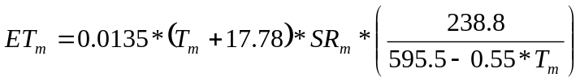 (1)
CMI is then calculated using the following equation:
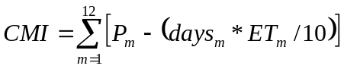 (2)
where P_{m} the precipitation in month m, days_{m} are the number of days in months m, and ET_{m} the daily evaporation in month m.

Descriptive statistics for the geographic variables along with the climatic variables used in the models are given in Table 2 and maps are provided in Figure 1. Correlation coefficients between selected variables are given in Table 3.

Needle Retention Model

A linear regression model was generated relating needle retention to January average temperature, July climate moisture index.

(3)

Statistics for the least squares (OLS) estimation of the model given by Equation 3 can be found in Table 4. Figure 2a show the difference between actual and predicted values for the OLS model. The residuals display visible evidence of clustering of residuals which is confirmed by the positive and significant values for the Moran’s I statistic shown in Table 4. Given the spatial bias indicated by the error maps and Moran’s I statistic the model was structured as a simultaneous autoregressive (SAR) model. The resulting model is described in equation 4.

(4)
where the autoregressive error term, u_{i}, is determined by the weighted values of the nearby plots as given in equation 5.

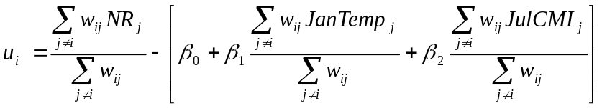 (5)
Given the lack of uniformity and gaps in the underlying plot data a simple inverse distance weighting scheme like Latta et al 2009 was deemed inappropriate. A negative exponential with parameters that determine both the slope of the weighting function and how far from the plot the downward slope begins was chosen. The slope of the weighting function is also adjusted by the average distance of the ten closest plots. This has the effect of creating a flatter slope when plots are scattered and a steeper slope when plots are dense. The flexible weighting function is given by equation.

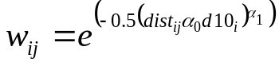 (6)

where dist_{ij} is the Euclidian distance between plots i and j, d10_{i} is the average Euclidian distance of the ten closest plots to plot i, and the values of α₀ and α₁ are 0.979 and 2.565 respectively. The resulting model is then solved using nonlinear least squares.

Results

Table 4 has the parameter estimates, asymptotic t ratios, coefficient of determination and spatial autocorrelation statistics for the model. The use of an autoregressive model improved the standard error by 16% ( 0.51 years for OLS and 0.43 years for SAR) while at the same time improving the r-squared of the model by 19% (0.61 for OLS and 0.72 for SAR). More importantly though, the SAR model shows no significant signs of spatial autocorrelation when evaluated either using a simple 0.25 decimal degree window (Moran’s I #3), inverse distance weighting (Moran’s I #2), or the exponential function of Equation 6 (Moran’s I #1). This can be seen in Figure 2b as the clustering of residuals of the OLS model in Figure 2a are no longer evident. Given the use of SAR model for needle retention maps which will then be used to estimate or impute needle retention for sites outside of the original dataset, the elimination of spatial bias is a primary goal.

Validation

To examine the usage of the methodology described above in imputing needle retention outside of the data used to derive the model we conduct an experiment where we randomly split the dataset into two groups of roughly 50%. The first set of 148 plots, reference plots, will be used to estimate the model using equations 4 – 6. That model will then be used to impute needle retention for the rest of the 147 plots, target plots. The r-square, bias, root mean square error, and spatial autocorrelation statistics will then be calculated as described in Latta etal (2009). This experiment was replicated 200 times and the results are presented in Table 5. In general the model tends to perform nearly as well with respect to r-square, bias, and root mean square error as the full dataset results of Table 4. In the two hundred replications, there were cases where there was significant clustering of residuals (positive Moran’s I with a Z-score greater than 2.0) however the clustering of residuals was not significant.

Needle Retention Map

In a similar process to that used in validating the model, we calculate needle retention for western Oregon forested land using data at a 90 meter pixel resolution. The base 90 meter digital elevation model is used to calculate slope and aspect at each pixel. The same process used to interpolate climate data to the plots is then used to get monthly temperature maximum and minimum values as well as precipitation. Solar radiation, evapotranspiration and CMI is then calculated for each pixel given its temperature, precipitation, slope, aspect and elevation. The 295 needle retention plots provide the neighborhood values for the autoregressive error term and the retention for each plot is calculated using Equation 4. The completed western Oregon needle retention map is presented in Figure 3.

Discussion

Needle retention on an individual tree is a result of many complex factors (Reich et al. 1995), but in the zone of the SNC epidemic on the west slope of the Oregon coast range, it appears that needle retention is closely associated with disease severity (Hansen et al. 2000, Maguire et al. 2002, Manter et al. 2003b). However, disease severity on the landscape is worse in low elevation sites, and impacts decrease with increasing elevation. Elevation is known as a major influence on needle retention of conifers as a general principle (Reich et al. 1996). Therefore both disease severity and elevation are interacting to influence needle retention in the zone of the SNC epidemic.

Since needle retention is a useful estimator of tree growth, a needle retention map can be used to predict landscape level growth impacts. If one assumes the reason that foliage retention drops below 3 along the Oregon coast is from Swiss needle cast disease, then calculating impacts is possible. Needle retention maps may provide an important aid in determining the severity of Swiss Needle Cast for specific areas, yet they do not provide an assessment of the volume growth impacts of disease to trees. Garber etal. 2006 estimated equations using needle retention to predict growth impacts of Douglas-fir. Figure 4 presents the diameter and height growth reductions from Garber etal. 2006 for a range of needle retention levels. When coupled with data from the Figure 3 map it becomes possible to examine the extent of potential growth reduction spatially. Table 6 shows the acreage and percentage of forest land by county for five percent diameter growth reduction classes. From this table it is evident that Tillamook and Clatsop county have the most acreage with greater than 25% diameter growth losses with twenty and thirteen percent respectively in this class.

Table 7 shows the acreages and forestland proportions of each western Oregon county by height growth loss classes. Given the more gradual decline of the height growth loss function in Figure 4 there isn’t substantial acreage that could expect height growth losses of more than twenty percent. Figure 5 maps the extent of the area that would receive diameter or height growth losses in excess of five percent and ten percent. These maps show that the largest area that would expect growth losses from swiss needle cast is along the northwestern coast of Oregon. There is another area with less dramatic losses where Douglas County reaches the Pacific Ocean and Northwestern Coos County. The last area expected to experience growth losses in excess of five percent is the coast fringe of Curry County.

Conclusion

Needle retention has become an important tool to assess growth in Douglas-fir influenced by Swiss needle cast foliage disease along the west slope of the Oregon Coast Range.

Our needle retention map coupled with a growth model modified with a disease growth loss estimator (ORGANON with SNC modifier, Garber et al. 2006) allowed for prediction of spatially distributed growth losses. This can be used in Integrated Pest Management strategies, economic and market analysis.

Literature Cited

Coops, N.C., R.H. Waring, and J.B. Moncrieff. 2000. Estimating mean monthly incident solar radiation on horizontal and inclined slopes from mean monthly temperature extremes. Int. J. of Biometeorology 44:204-211.

Daly, C., G.H. Taylor, W. P. Gibson, T.W. Parzybok, G. L. Johnson, P. Pasteris. 2001. High-quality spatial climate data sets for the United States and beyond. Transactions of the American Society of Agricultural Engineers, 43: 1957-1962.

Filip, G., A. Kanaskie, W. Littke, J. Browning, D. Hildebrand, and D. Maguire. 2006. Pages 12-19, in: D. Shaw, Editor, 2006 Swiss Needle Cast Cooperative Annual Report. (website access: ).

Garber, S, D Maguire, D Mainwaring, and D Hann. 2007. Swiss Needle Cast ORGANON Module Update. Pp. 63-66 in D. Shaw (ed). Annual Report 2007, Swiss Needle Cast Cooperative, College of Forestry, Oregon State University, Corvallis, OR.

Hann, D.W. 2006. ORGANON user’s manual. Edition 8.2 (computer manual). Oregon State University, Dept. of Forest Resources, Corvallis, OR.

Hansen, E.M., Stone, J.K., Capitano, B.R., Rosso, P., Sutton W., Winton L., Kanaskie A., and M.G. McWilliams. 2000. Incidence and impact of Swiss needle cast in forest plantations of Douglas-fir in coastal Oregon. Plant Disease. 84: 773-779.

Latta, G., H. Temesgen and T. Barrett. 2009. Mapping and imputing potential productivity of Pacific Northwest Forests using climate variables. Can. J. For. Res. 39:1197-1207.

Maguire D.A., Kanaskie A., Voelker W., Johnson R., and G. Johnson. 2002. Growth of young Douglas-fir plantations across a gradient in Swiss needle cast severity. West. Jour. of Ap. For. 17: 86-95.

Mainwaring, D.B., D.A. Maguire, A. Kanaskie, J. Brandt. 2005. Growth responses to commercial thinning in Douglas-fir stands with varying severity of Swiss needle cast in Oregon, USA. Canadian Journal of Forest Research 35: 2394-2402.

Mainwaring, D. and D. Maguire. 2008. Growth responses to pre-commercial thinning under different levels of initial SNC severity of north coastal Oregon. Pages 18 – 20, in; D. Shaw and T. Woolley, 2008 Swiss Needle Cast Cooperative Annual Report. Department of Forest Engineering, Resources and Management, College of Forestry, Oregon State University (website: )

Manter, D.K., Bond, B.J., Kavanagh, K.L., Stone, J.K., and G.M. Filip. 2003a. Modelling the impacts of the foliar pathogen, Phaeocryptopus gaeumannii, on Douglas-fir physiology: net canopy carbon assimilation, needle abscission and growth. Ecological Modeling. 164: 211-226.
Manter, D.K., Winton, L.M., Filip, G.M., and J. K. Stone. 2003b. Assessment of Swiss Needle Cast Disease: Temporal and Spatial Investigations of Fungal Colonization and Symptom Severity. Phytopath-Z. 151:344-351.

Narongrit, C. and Y. Yasuoka. 2003. The use of terra-MODIS data for estimating evapotranspiration and its change caused by global warming. Env. Inf. Arch. 1: 505-511

Reich, P. B., T. Koike, S.T. Gower, and A.W. Schoettle. 1995. Causes and consequences of variation in conifer leaf life-span. In: Ecophysiology of coniferous forests. Edited by: W.K. Smith and T.M. Hinckley. Academic Press, NY, pp. 225-254.

Wang, T., A. Hamann, D. Spittlehouse, and S. Aitken. 2006. Development of scale-free climate data for western Canada for use in resource management. Int. J. of Climatology 26: 383-397

Winton, L.M., Manter, D.K., Stone, J.K., and E.M. Hansen. 2003. Comparison of biochemical, molecular and visual methods to quantify Phaeocryptopus gaeumannii. Douglas-fir foliage. Phytopathology. 93: 121-126.

Table 1. SNC Data sources and plot count

 | Number of Plots
CT_Perm | 33
CT_Retro | 44
Filip | 55
GIS | 77
Mainwaring | 1
PCT | 23
Summer09 | 62

Table 2. Summary statistics for the SNC data

Variable |  | Mean | Median | Maximum | Minimum | Std. Dev.
 | Needle Retention (years) | 2.9 | 2.7 | 5.3 | 1.2 | 0.82
Geographic
 | Latitude (°) | 44.9 | 45.1 | 46.6 | 42.1 | 0.93
 | Longitude (°) | -123.5 | -123.7 | -122.0 | -124.3 | 0.59
 | Elevation (m) | 369 | 306 | 1280 | 9 | 258.79
Climatic
 | Annual Temperature (°C) | 10.5 | 10.5 | 12.8 | 6.8 | 1.05
 | Annual Precipitation (cm) | 243.6 | 237.1 | 449.9 | 130.9 | 60.73
 | January Temperature (°C) | 5.5 | 5.6 | 9.0 | 0.6 | 1.62
 | July CMI (cm) | -12.4 | -12.6 | -7.7 | -15.7 | 1.65

Table 3. Correlation matrix for the SNC data

 | NR | Lat | Lon | Elev | T_{ann} | P_{ann} | T_{Jan} | CMI_{Jul}
Needle Retention (NR) | 1
Latitude (Lat) | -0.15 | 1
Longitude (Lon) | 0.69 | 0.18 | 1
Elevation (Elev) | 0.60 | -0.04 | 0.67 | 1
Annual Temperature (T_{ann}) | -0.37 | -0.57 | -0.64 | -0.70 | 1
Annual Precipitation (P_{ann}) | -0.39 | 0.44 | -0.26 | 0.08 | -0.28 | 1
January Temperature (T_{Jan}) | -0.61 | -0.43 | -0.82 | -0.78 | 0.91 | -0.07 | 1
July CMI (CMI_{Jul}) | -0.53 | 0.65 | -0.30 | -0.35 | -0.19 | 0.59 | 0.08 | 1

Table 4. Correlation matrix for the SNC data

 |  | OLS | SAR
Parameter Statistics
 | ρ |  | 0.97 (15.0)
 | β₀ | 1.44 (5.6) | 4.38 (1.4)
 | β₁ | -0.29 (-15.6) | -0.26 (-5.9)
 | β₂ | -0.24 (-13.3) | -0.09 (-3.3)
Equation Statistics
 | r² | 0.61 | 0.72
 | S.E. | 0.51 | 0.43
Spatial Autocorrelation Statistics
 | Moran's I #1 | 0.27 (4.3) | -0.05 (-0.8)
 | Moran's I #2 | 0.17 (2.8) | -0.01 (-0.2)
 | Moran's I #3 | 0.19 (3.0) | -0.02 (-0.4)
Notes: t statistics in parentheses. Moran's I #1 is with exponential weighting, Moran's I #2 is inverse distance weighting, and Morans I #3 is no wieghting, but within a distance of 0.25 degrees

Table 5. Statistics from 200 replications

Statistic | Mean | Median | Maximum | Minimum | Std. Dev.
r² | 0.70 | 0.70 | 0.57 | 0.79 | 0.04
RMSE | 0.45 | 0.45 | 0.39 | 0.52 | 0.02
Bias | 0.00 | 0.01 | -0.16 | 0.15 | 0.05
Moran's I | 0.10 | 0.10 | -0.01 | 0.28 | 0.06
Moran's I SE | 0.09 | 0.09 | 0.09 | 0.09 | 0.00
Moran's I Z | 1.04 | 1.02 | -0.23 | 3.05 | 0.69

Table 6. Extent of Douglas-fir diameter growth reduction by county

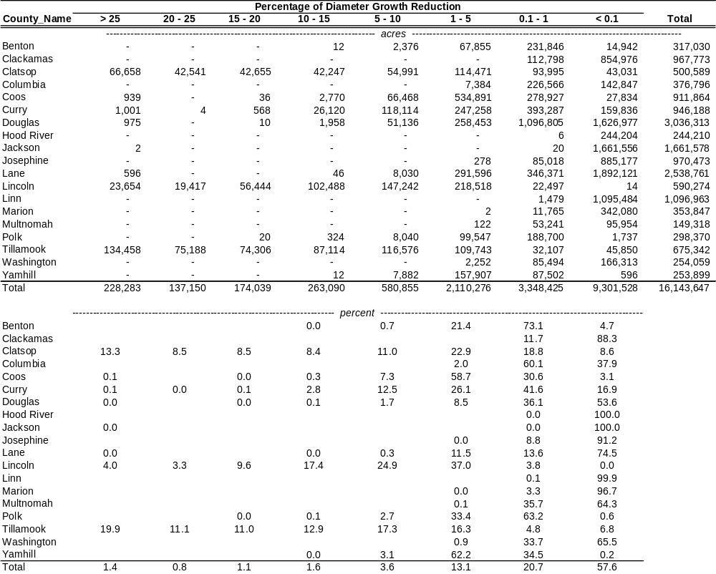
Table 7. Extent of Douglas-fir height growth reduction by county

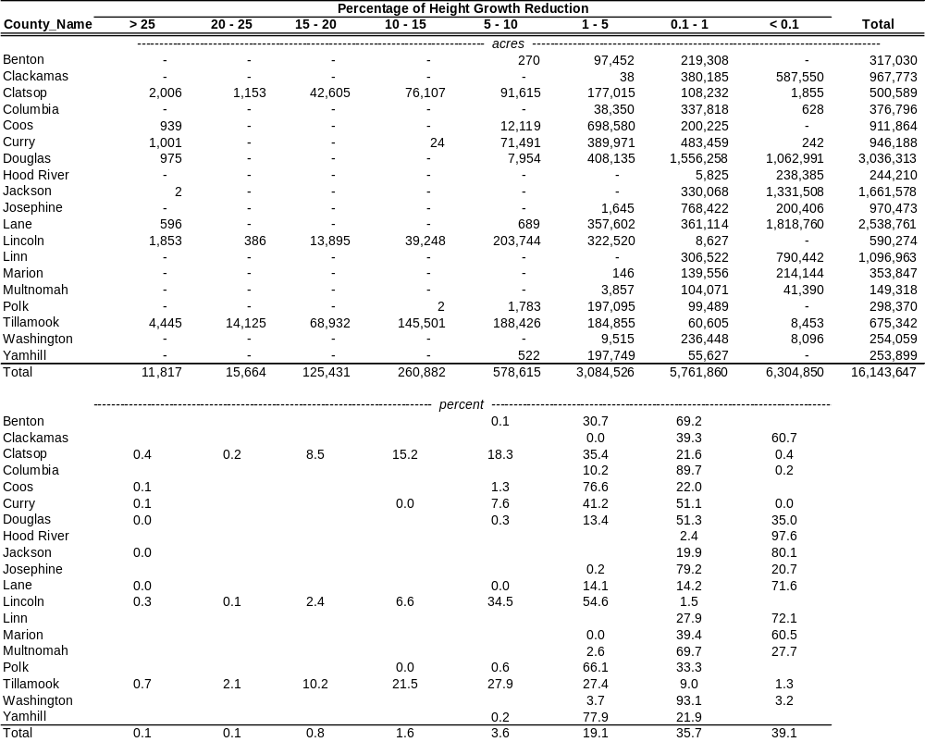

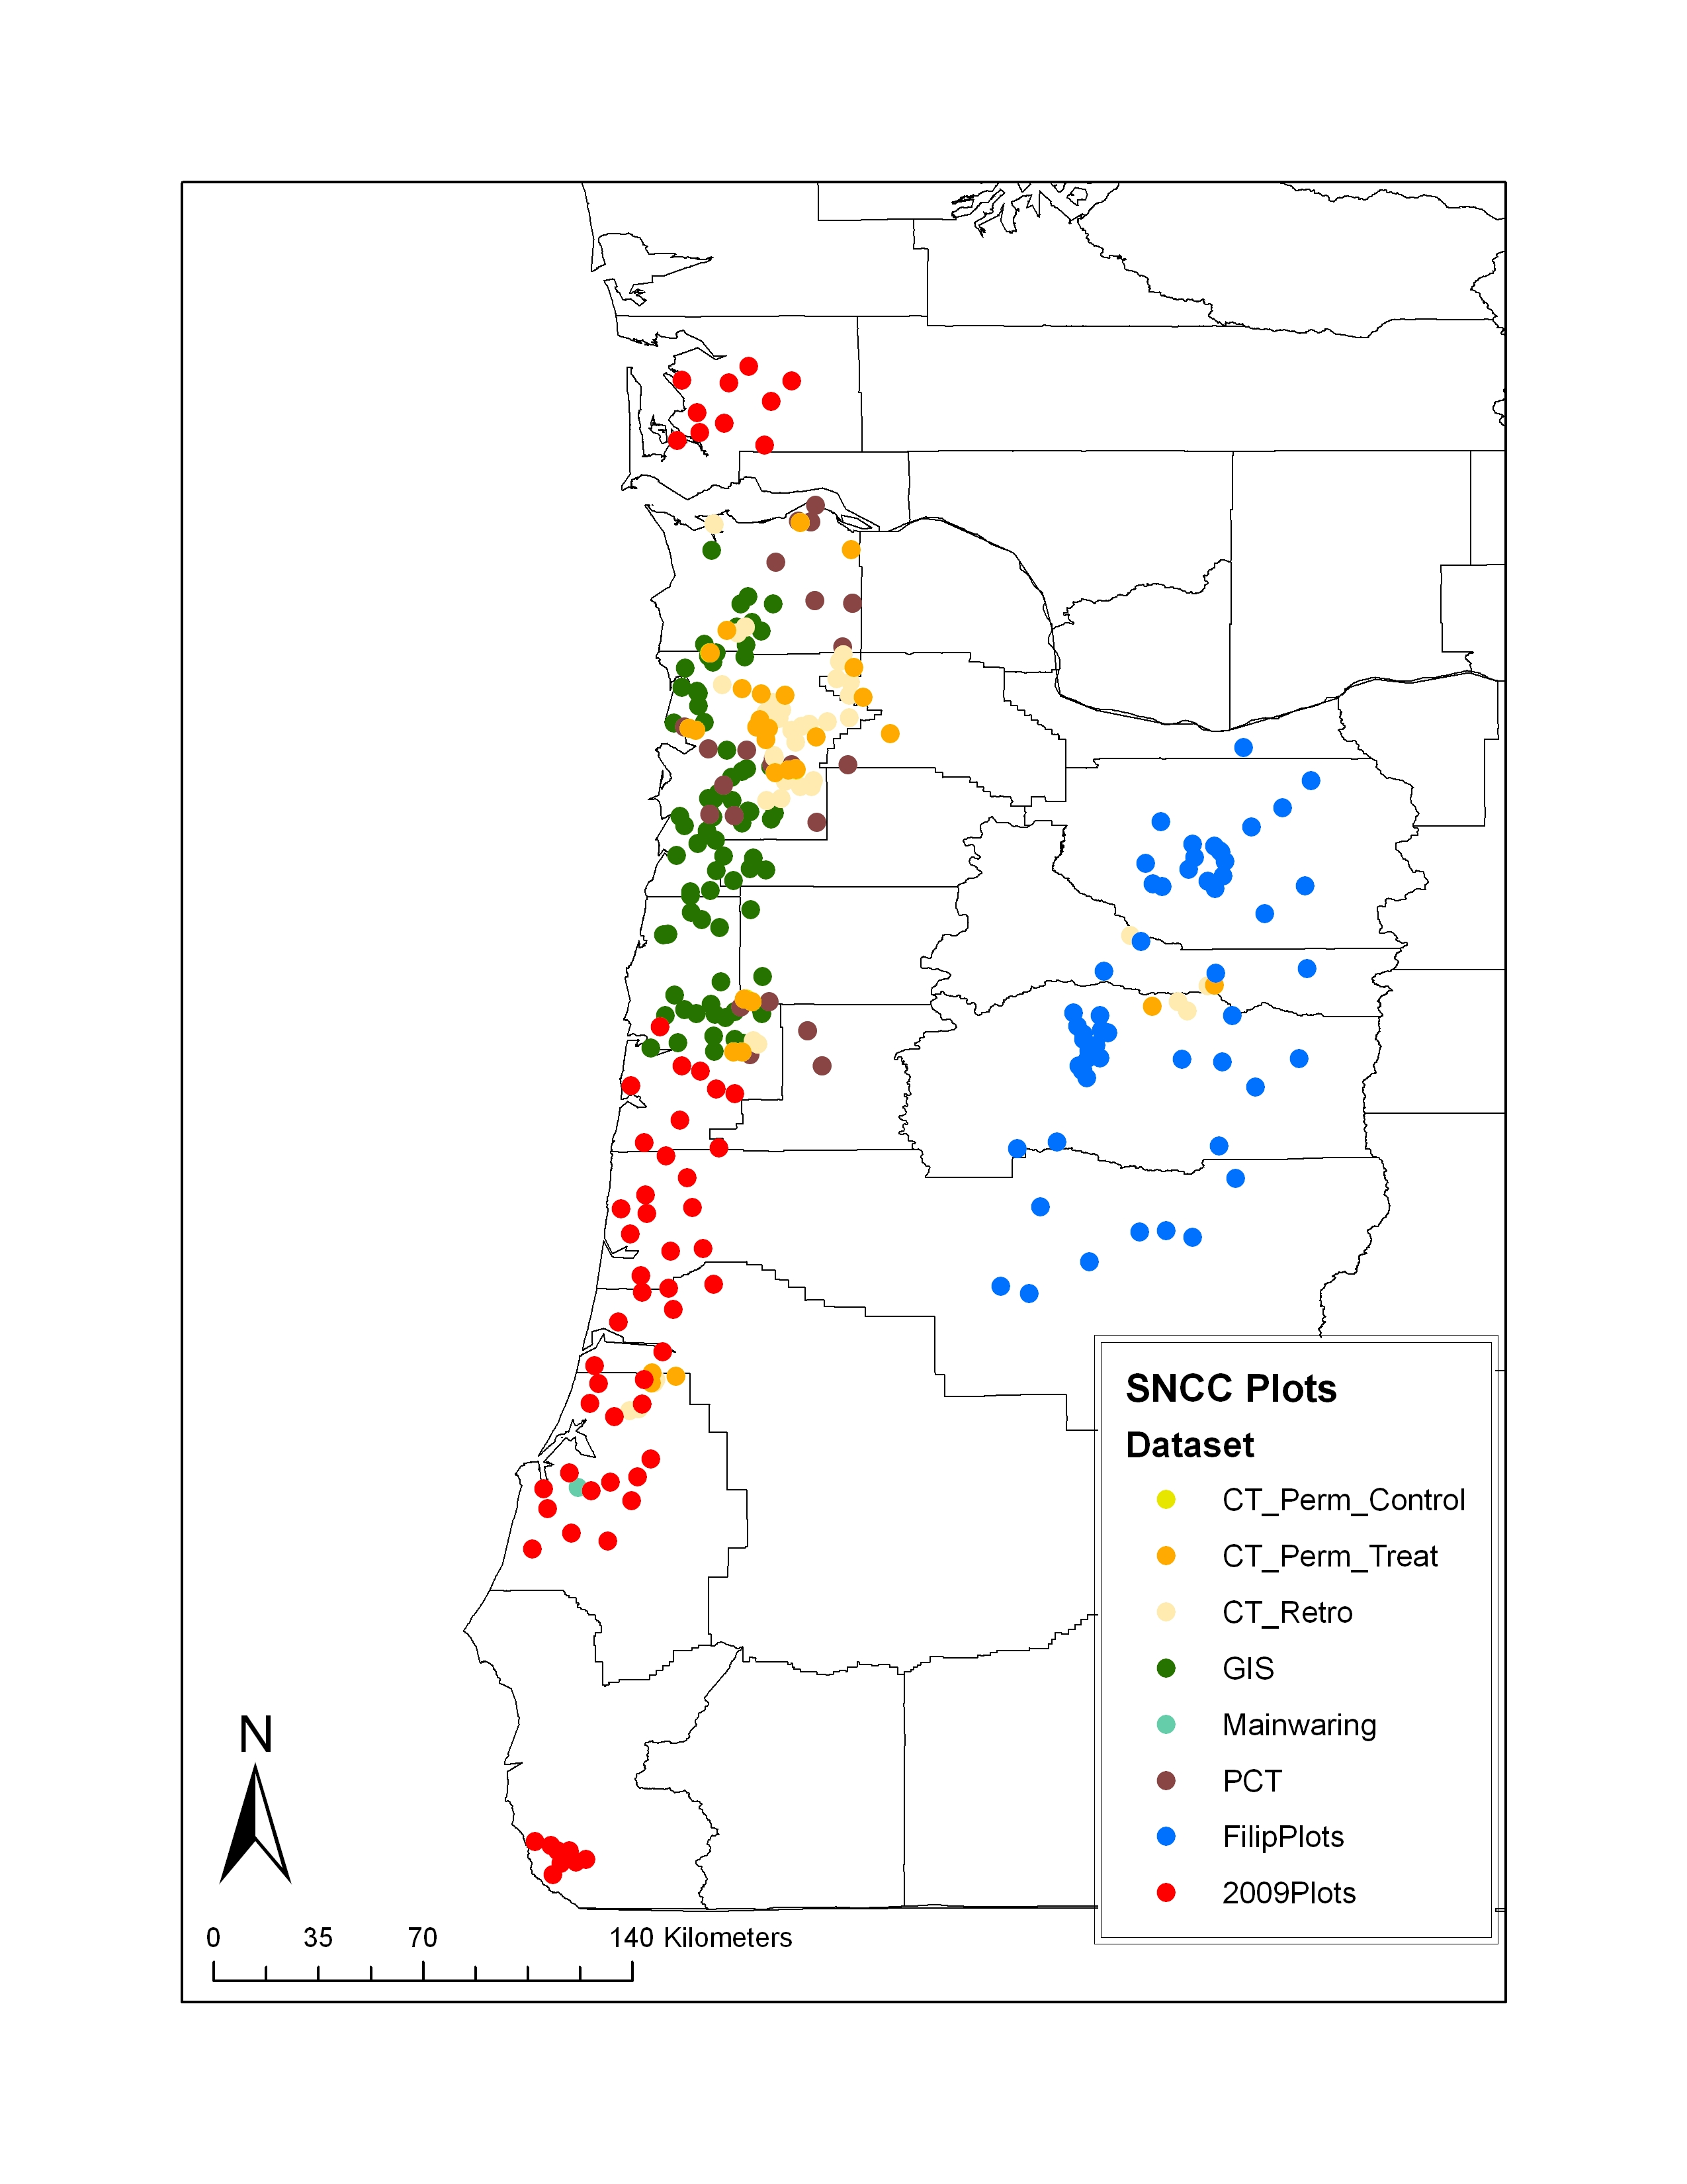
Figure 1. SNC Plot Location

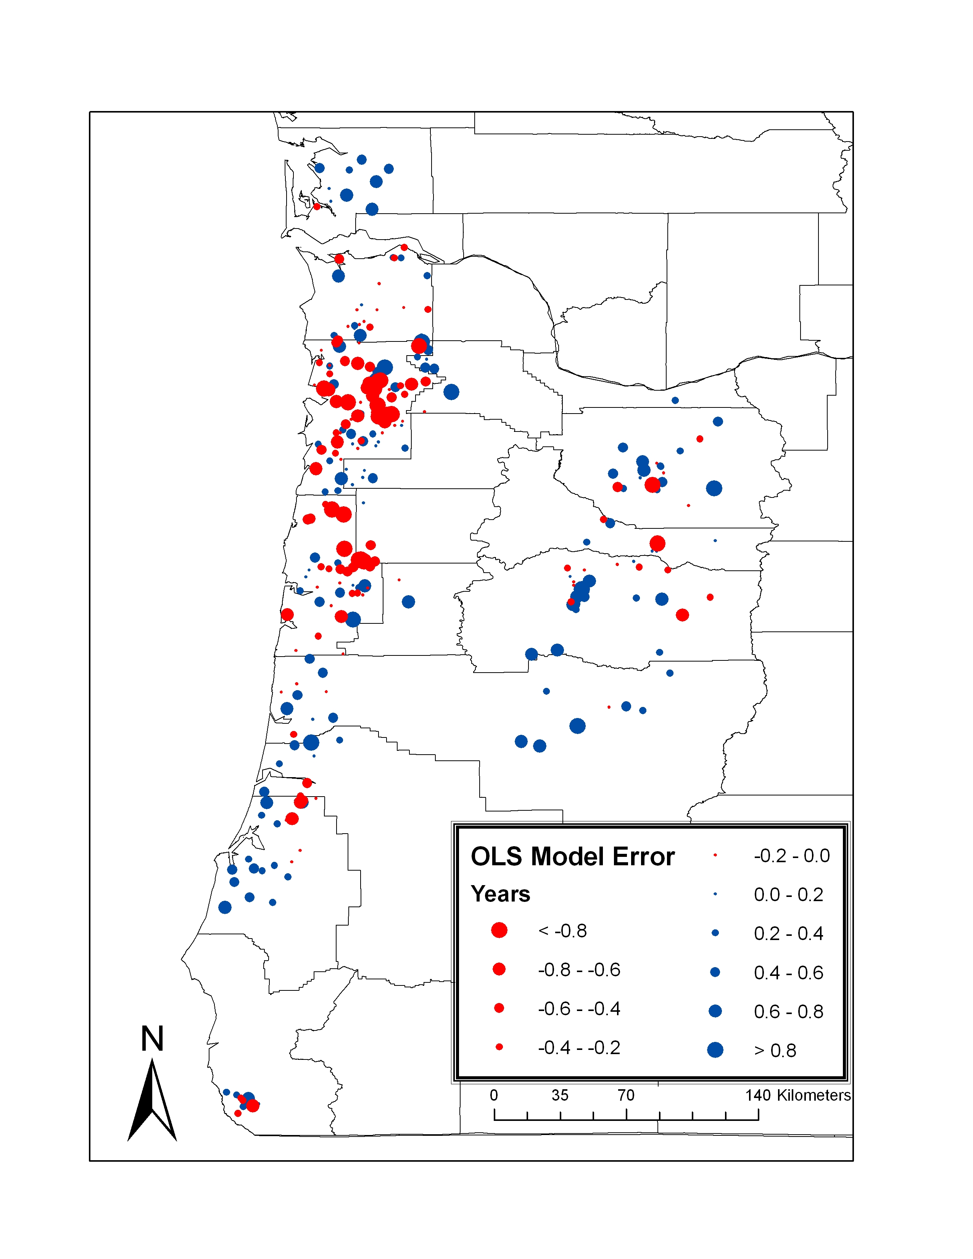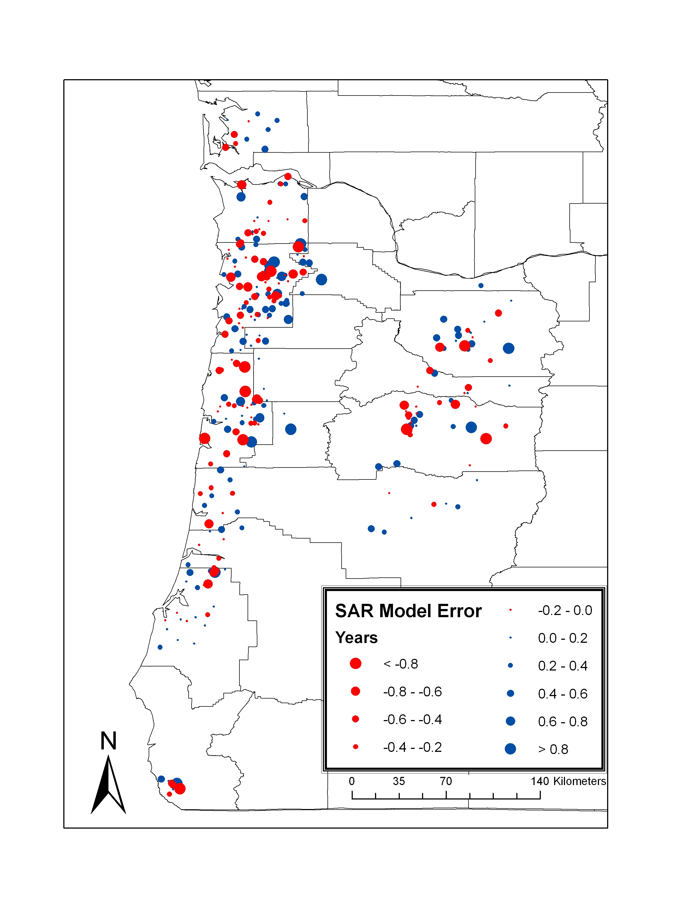
a)
b)
Figure 2. Model error maps (Error = NR_{Actual} – NR_{Estimated}) in years

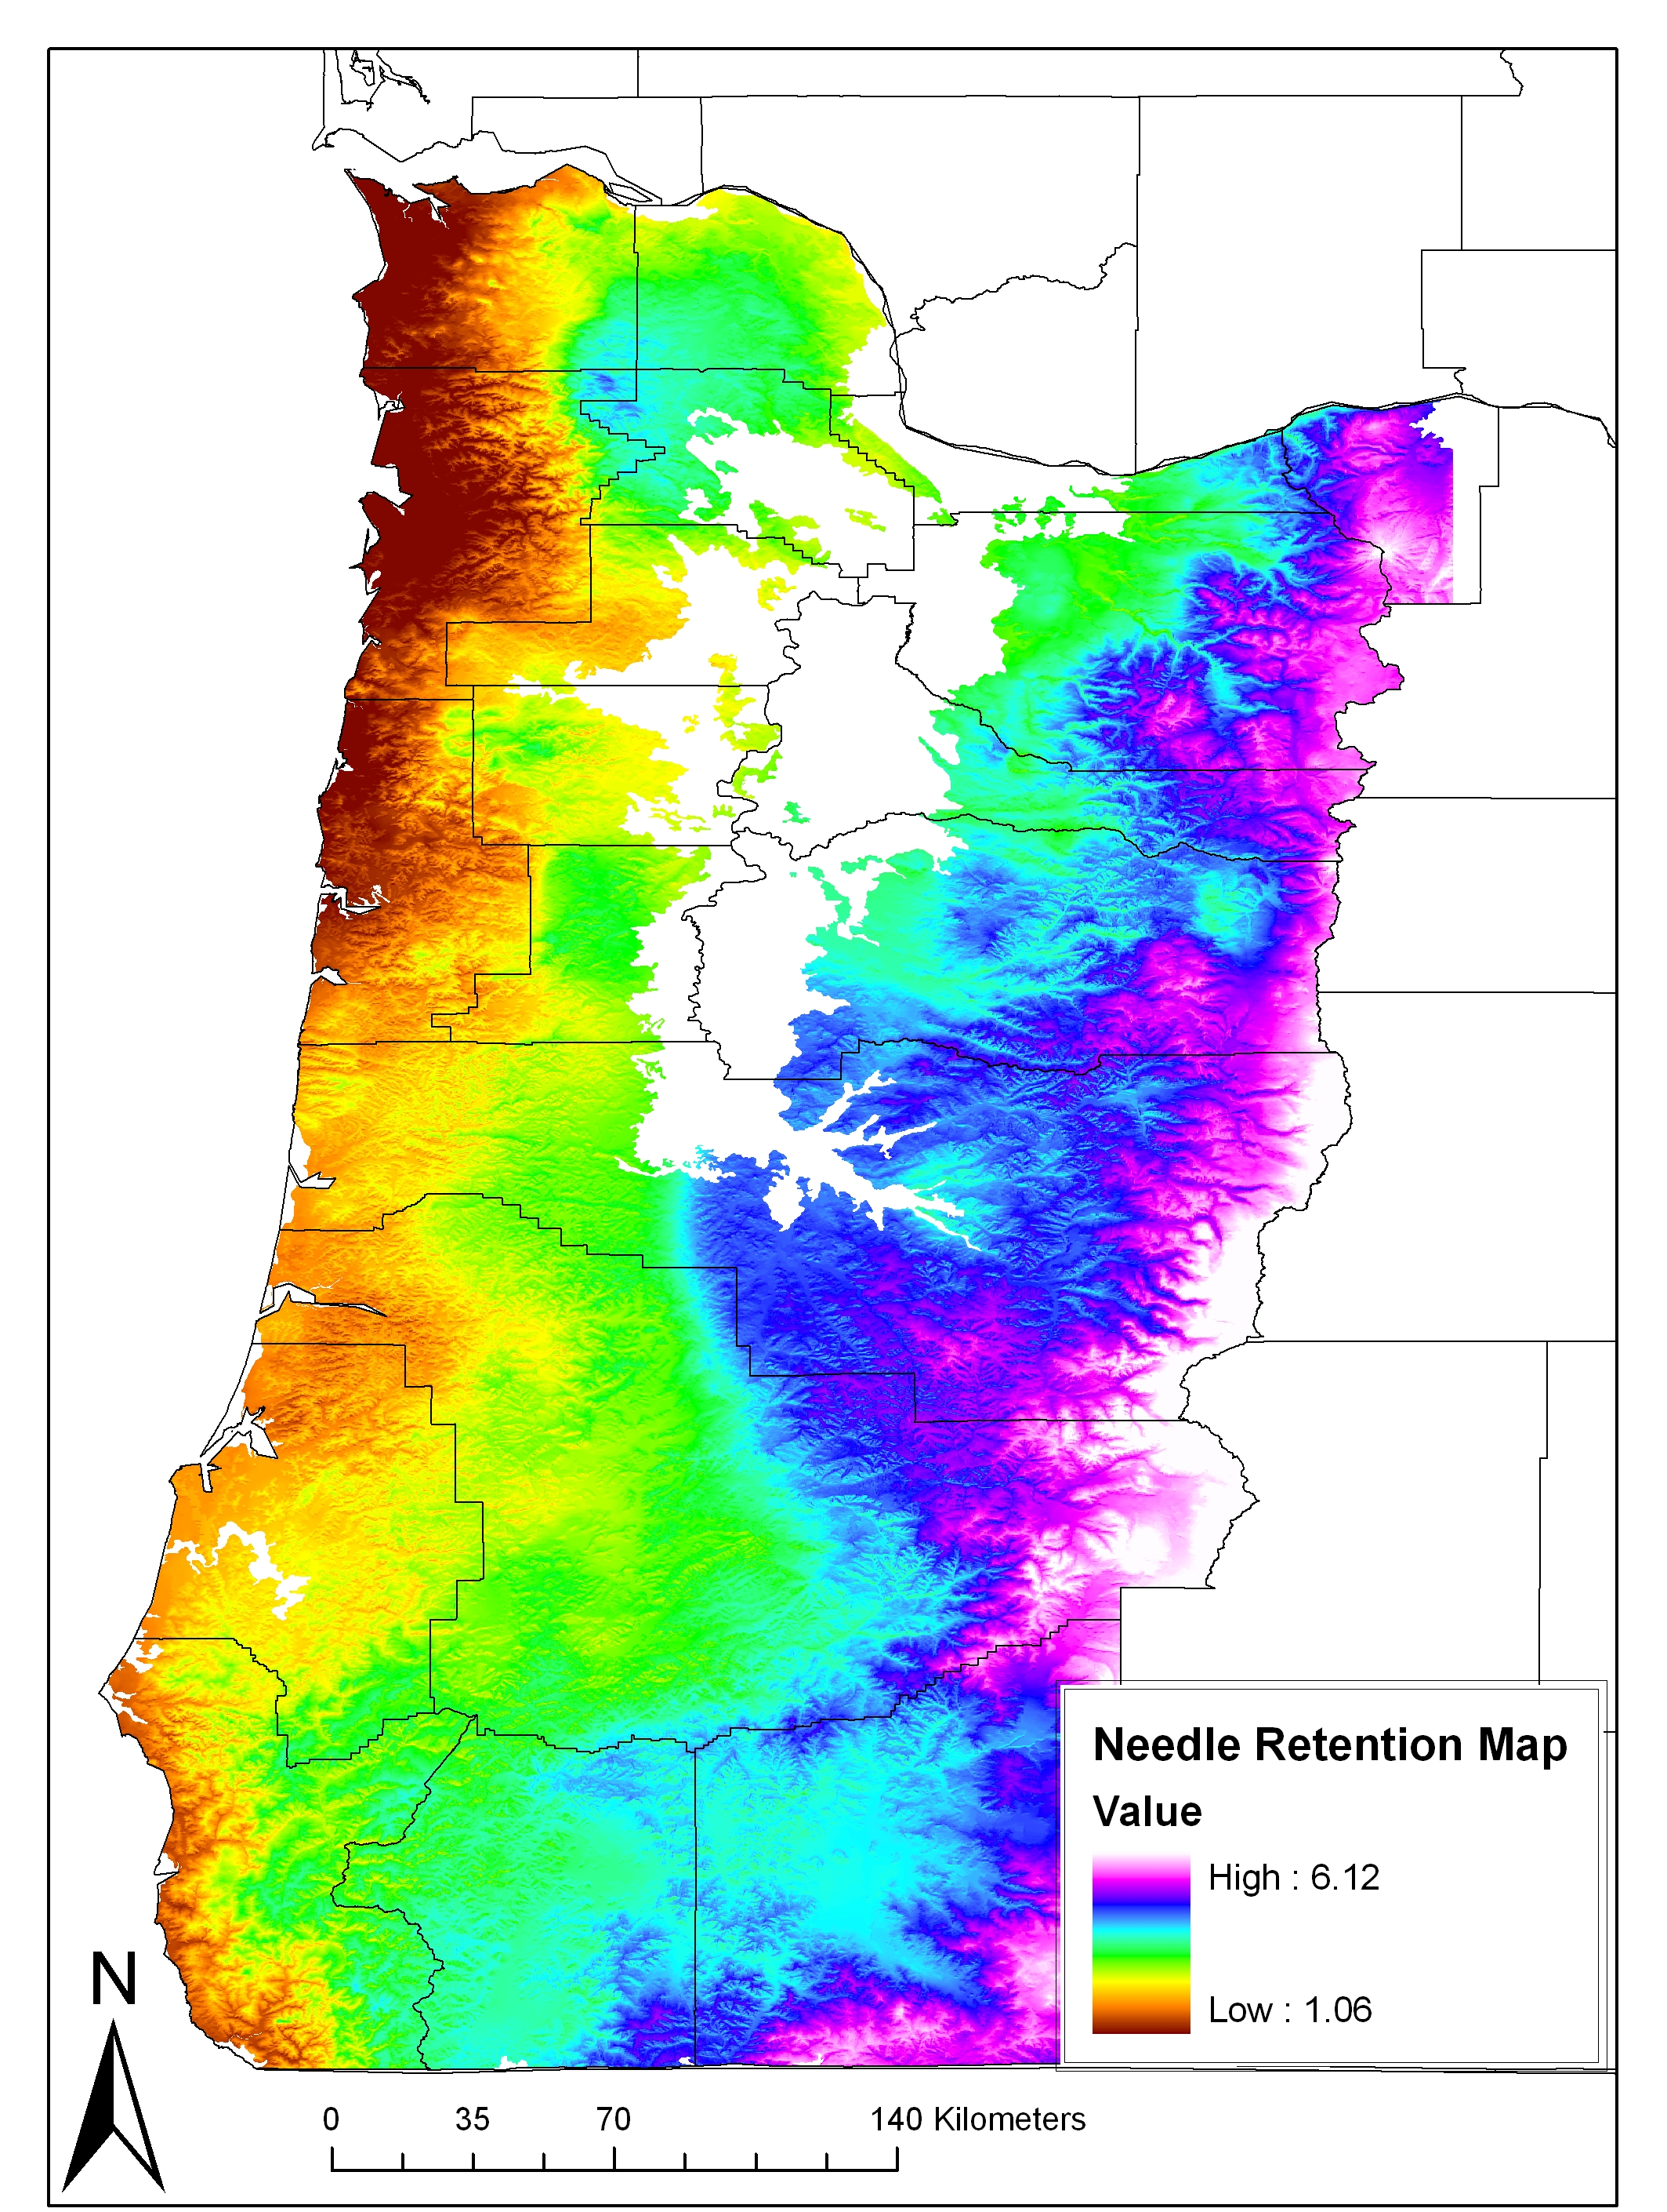
Figure 3. Douglas-fir needle retention map for forested land in western Oregon

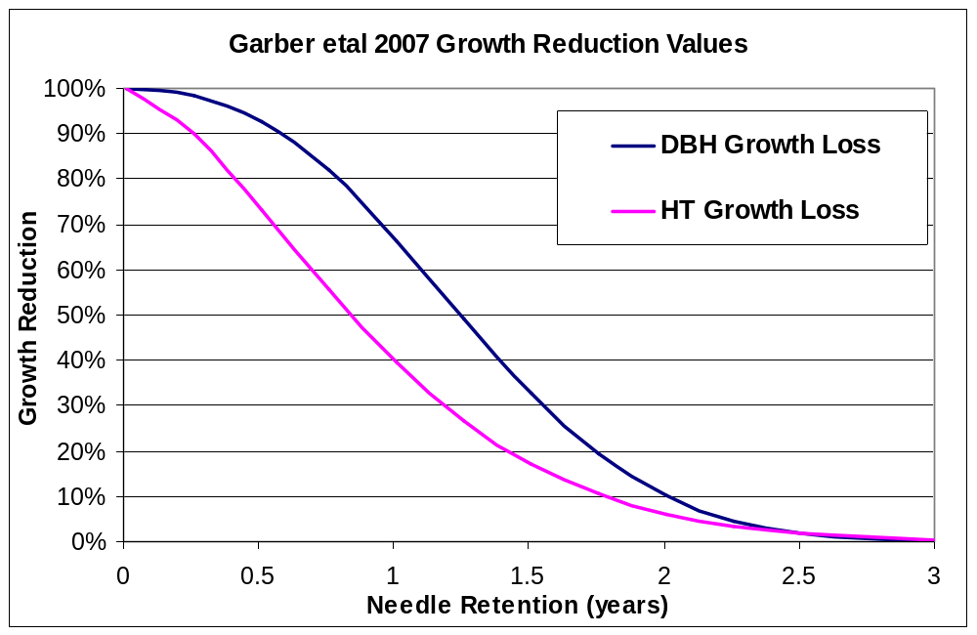
Figure 4. Growth reduction related to needle retention

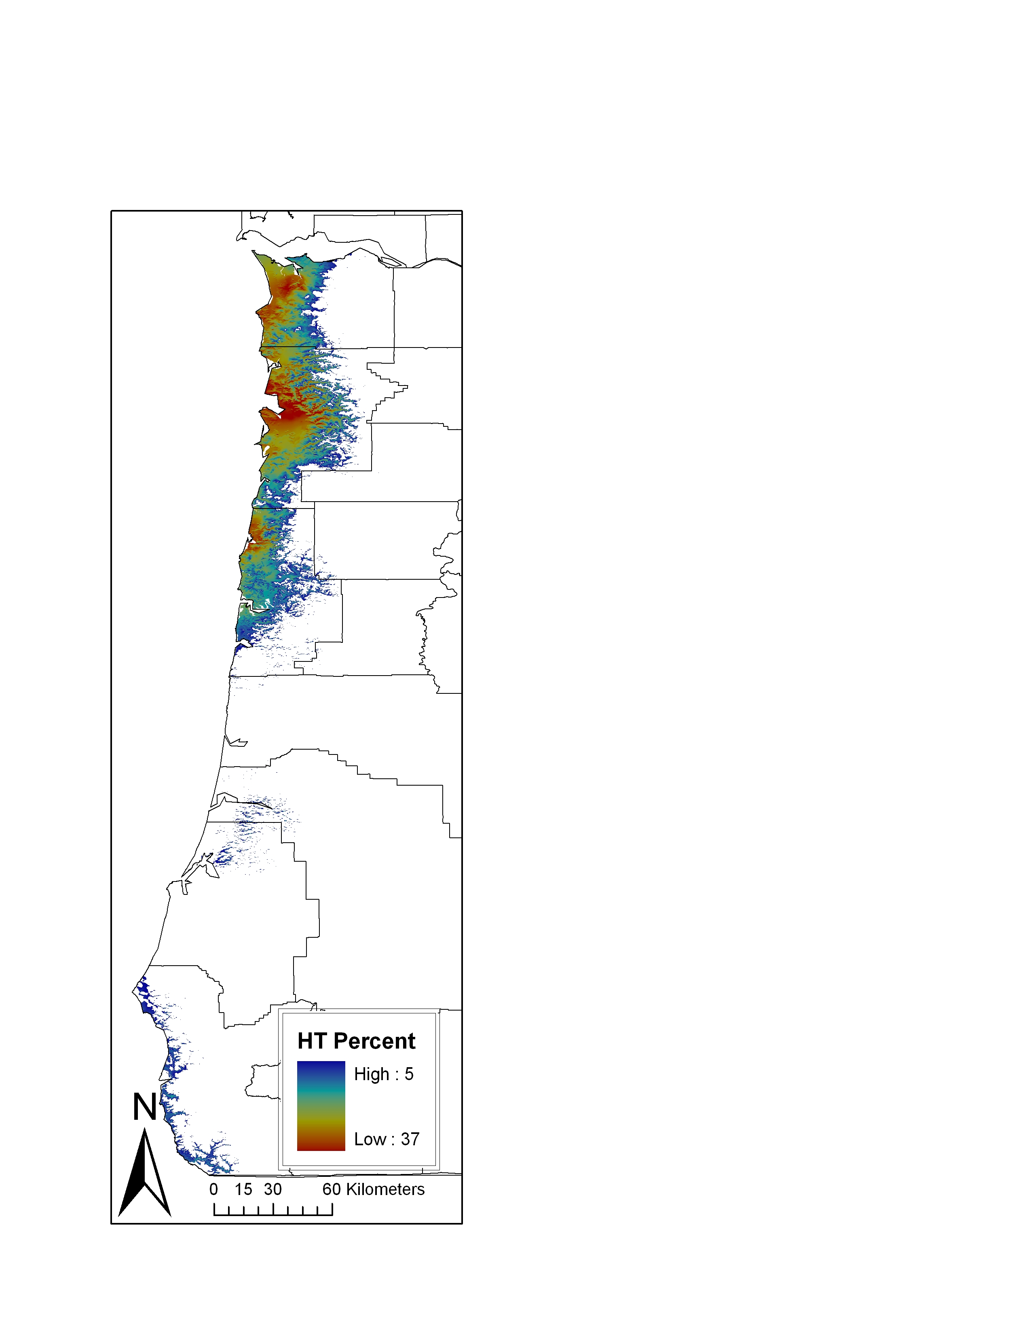
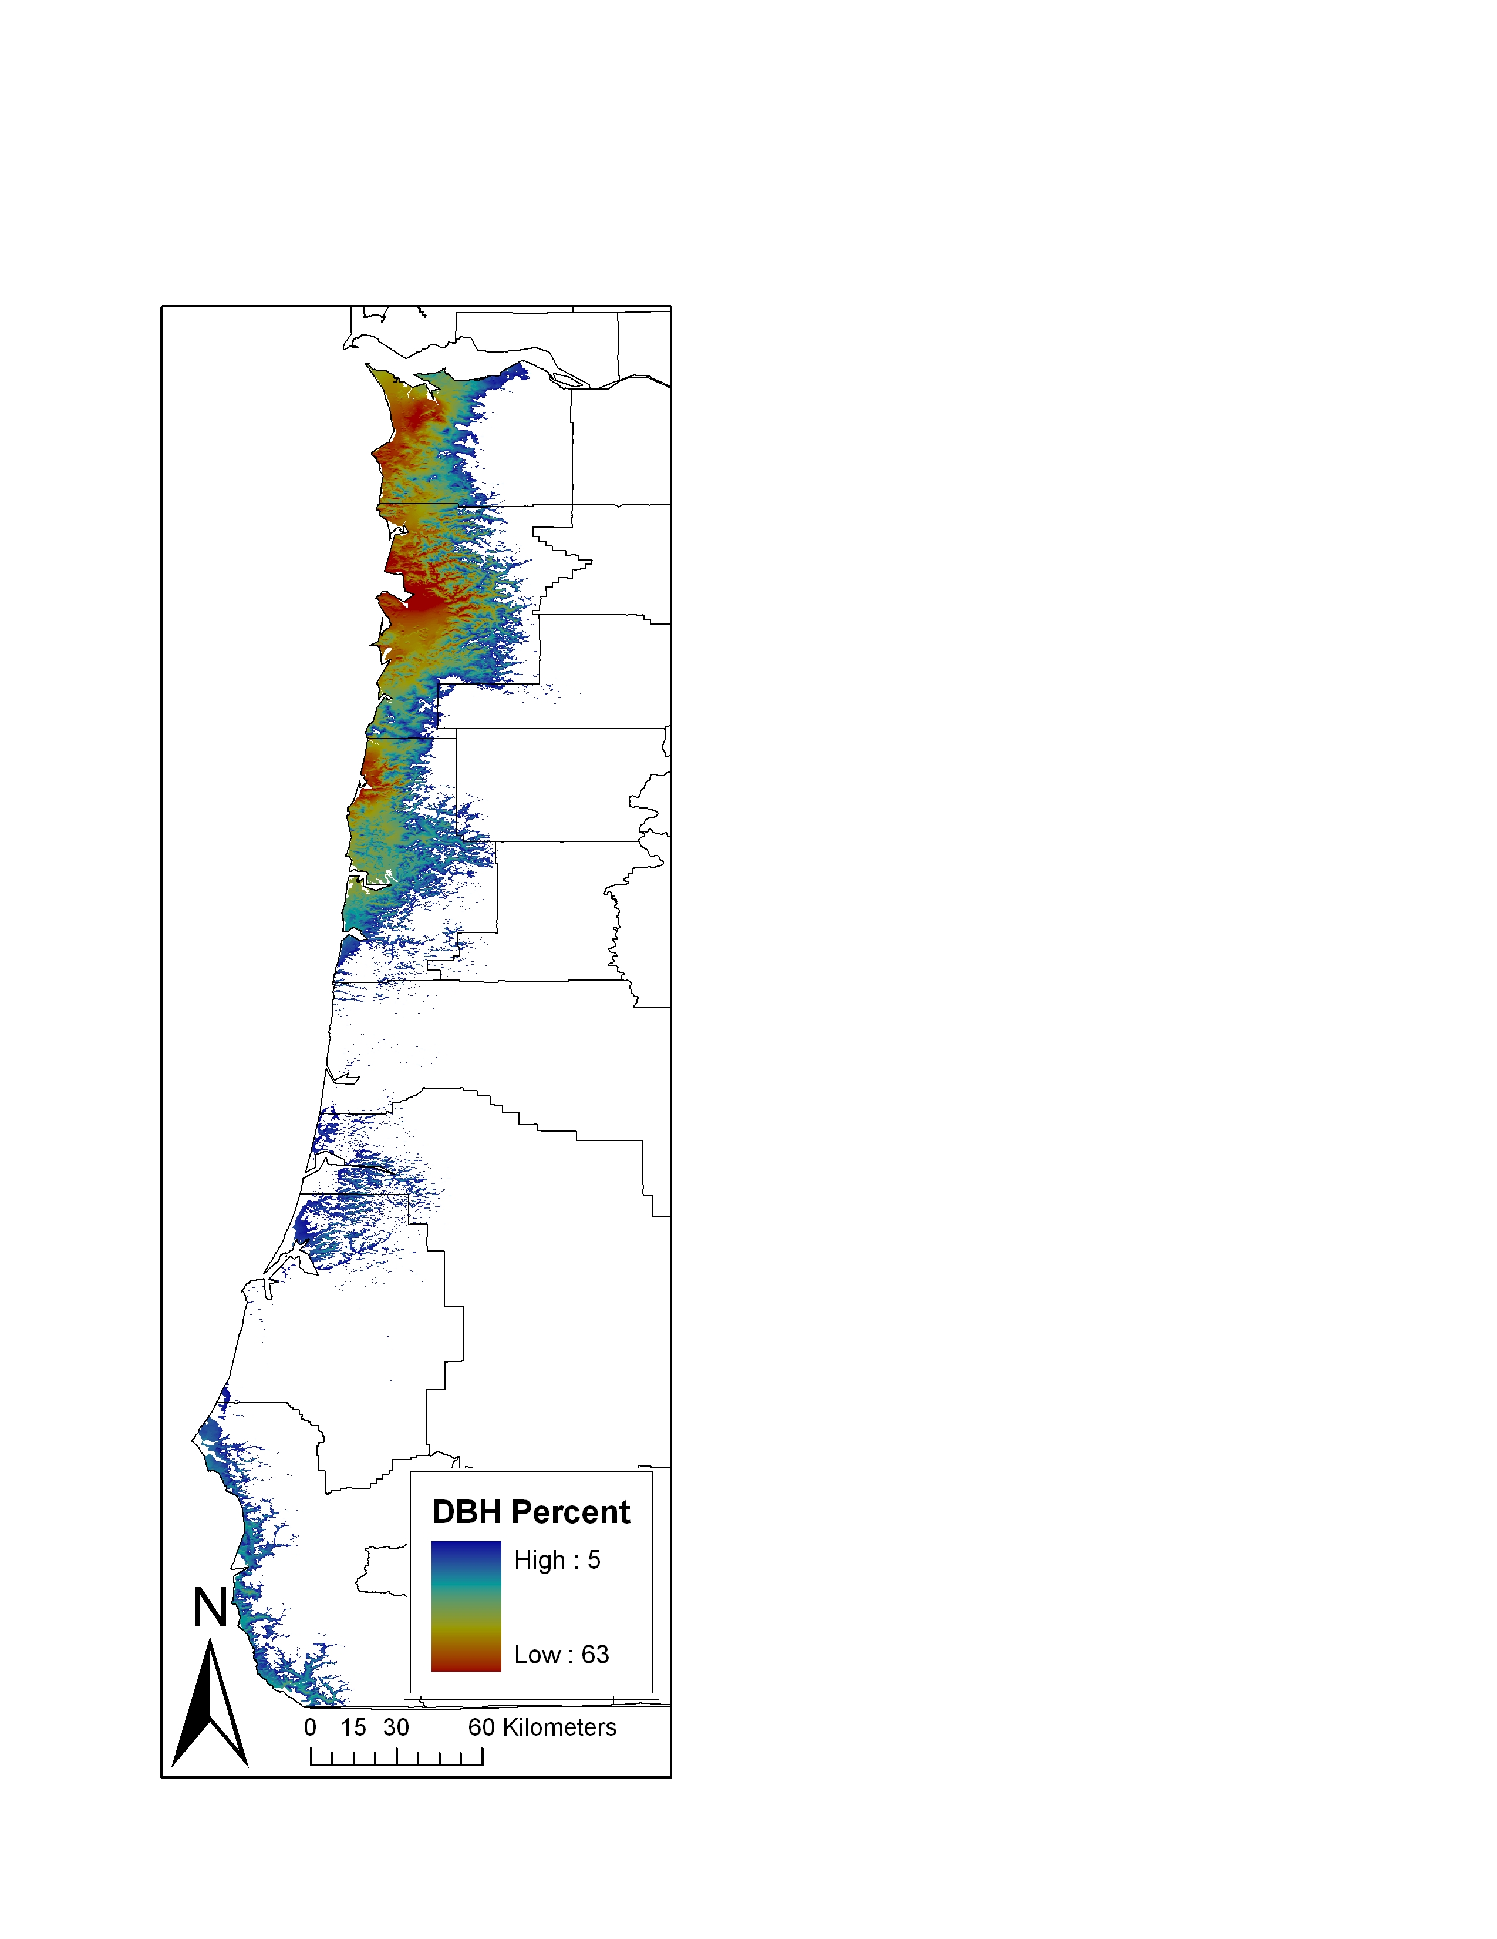
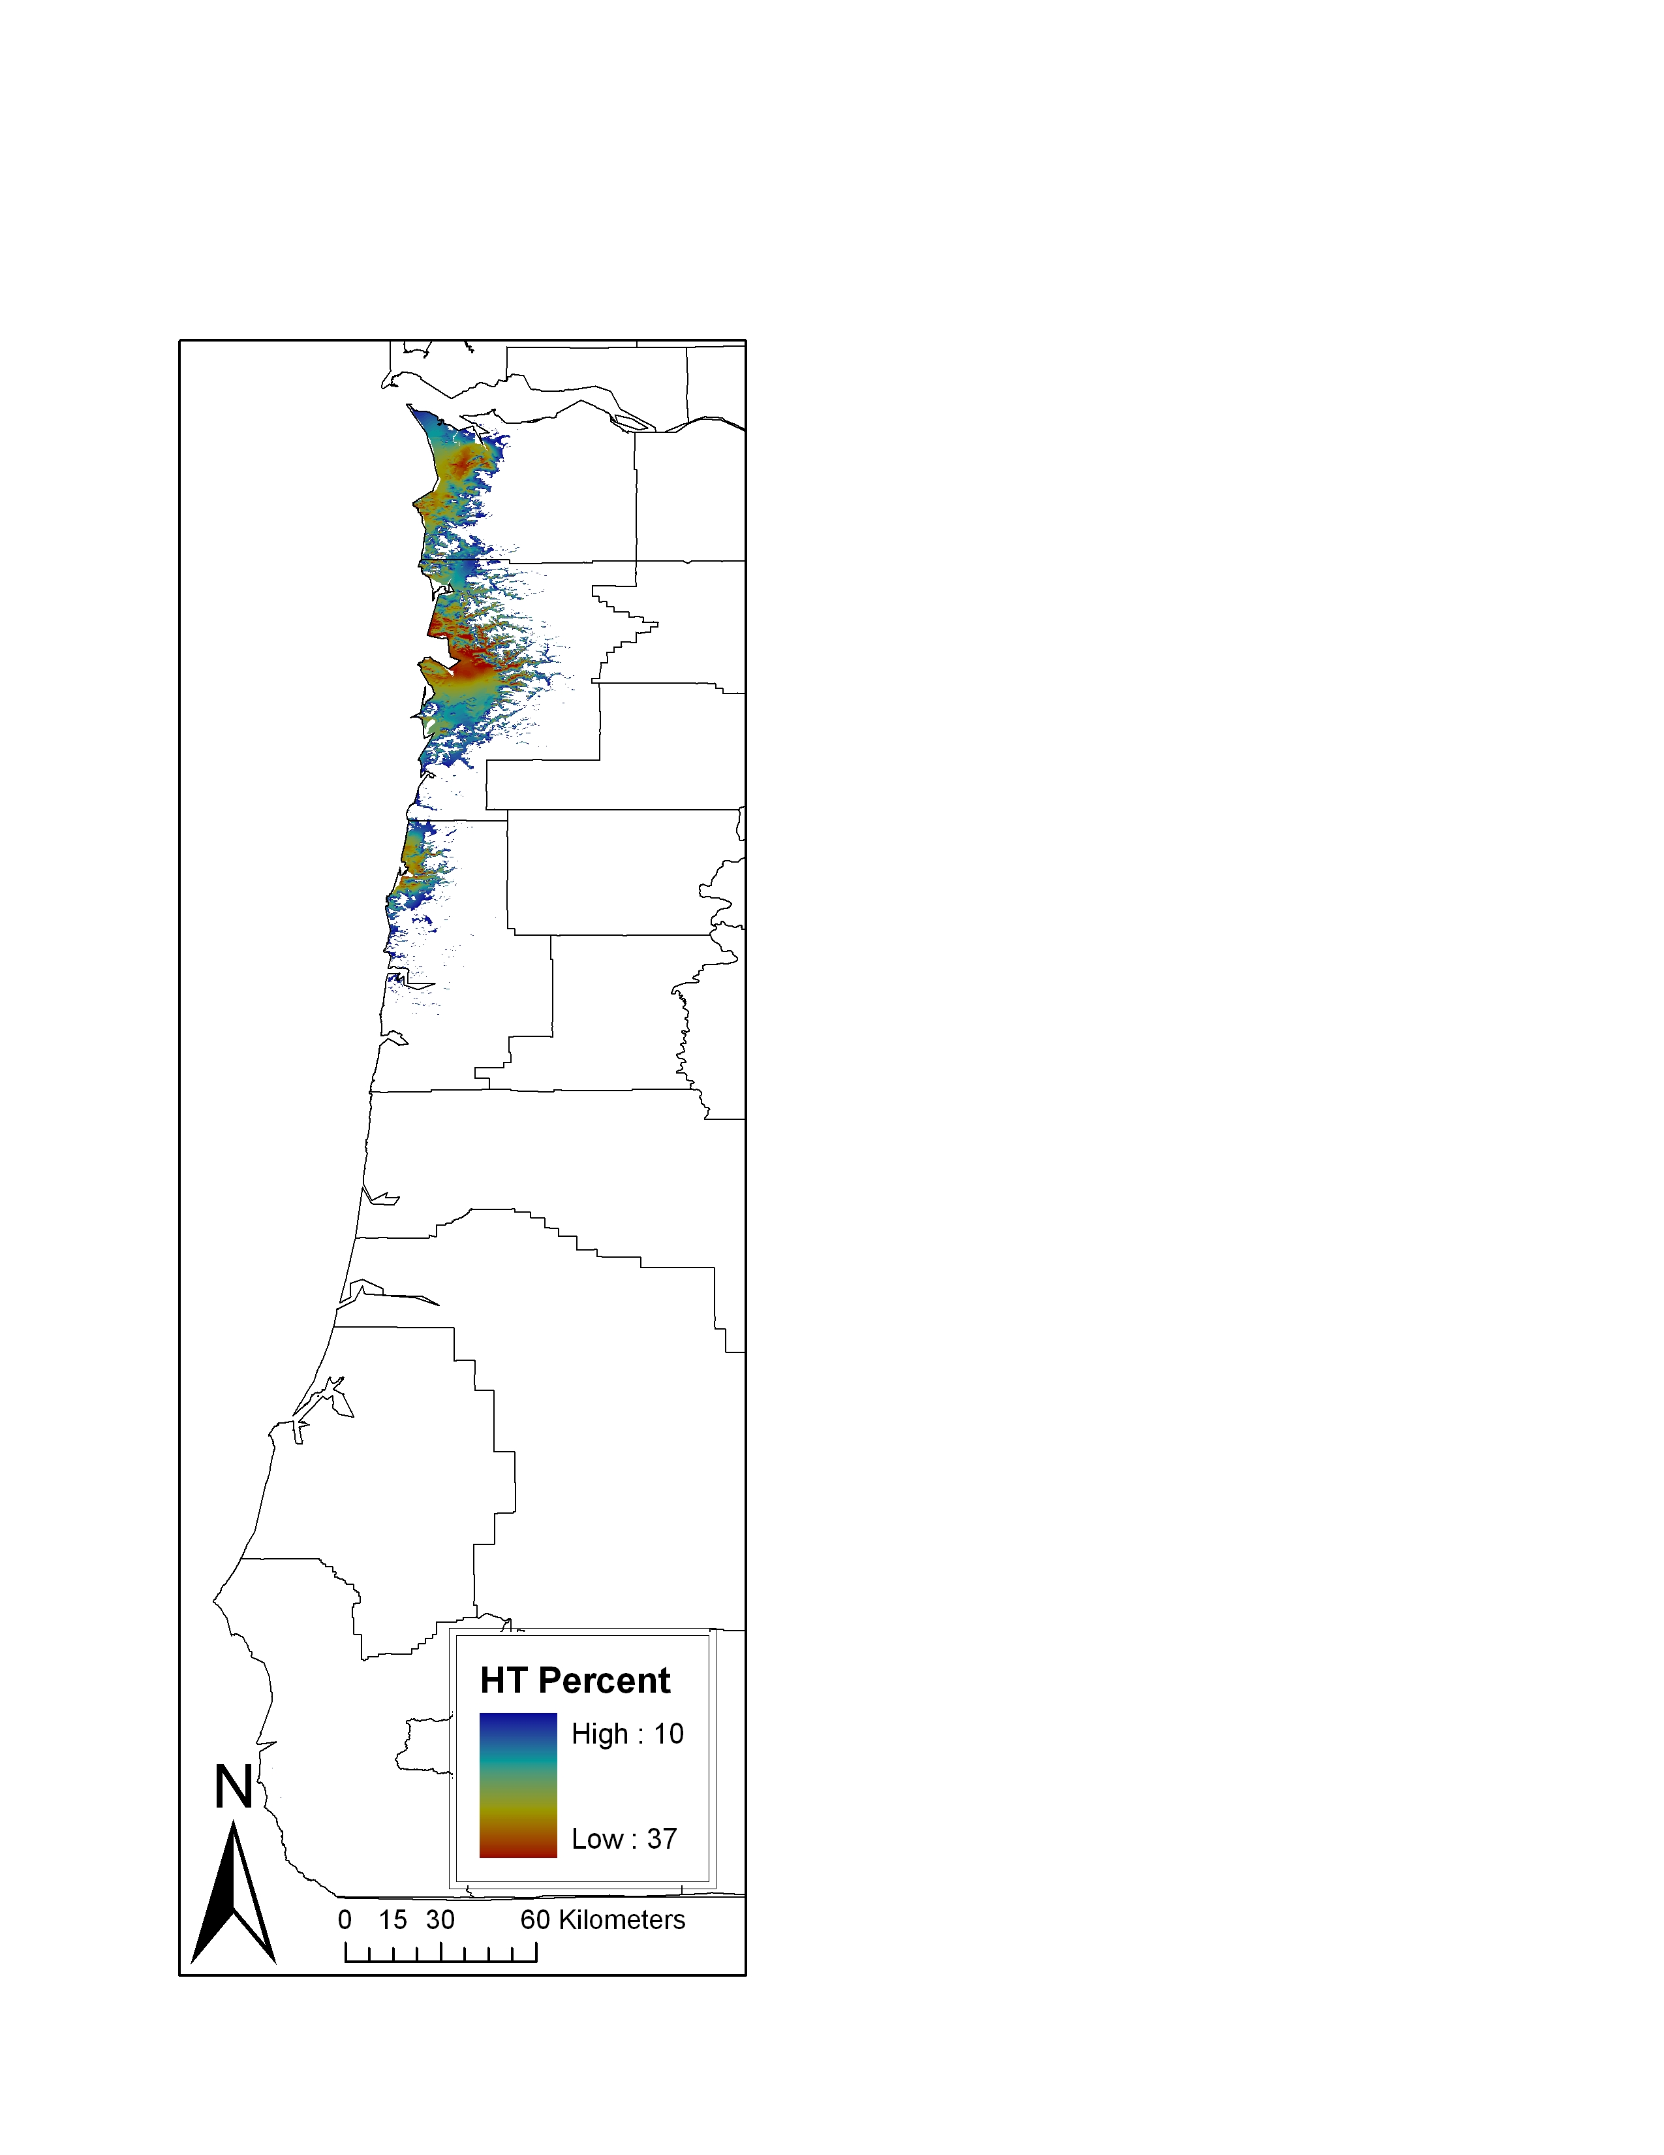
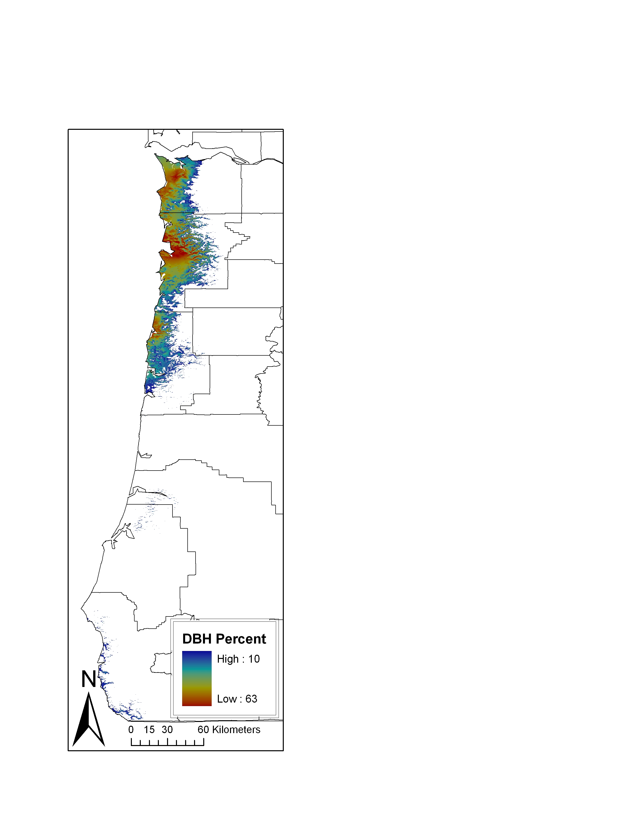
Diameter
Height
Diameter
Height
Extent of 5% Growth Impacts
Extent of 10% Growth Impacts
Figure 5. Maps of 5 and 10 % growth impact zones

